MYP-1500Q
Lead Edge Automatic Die Cutting&Creasing Machine With Stripping Unit Product Introduction
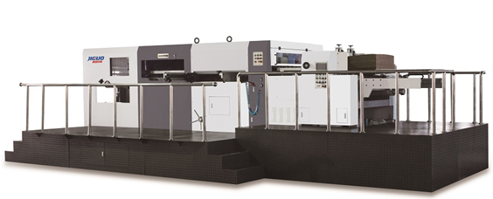

Tangshan Jiguo Printing Machinery Co.,Ltd.
en.jiguo.net
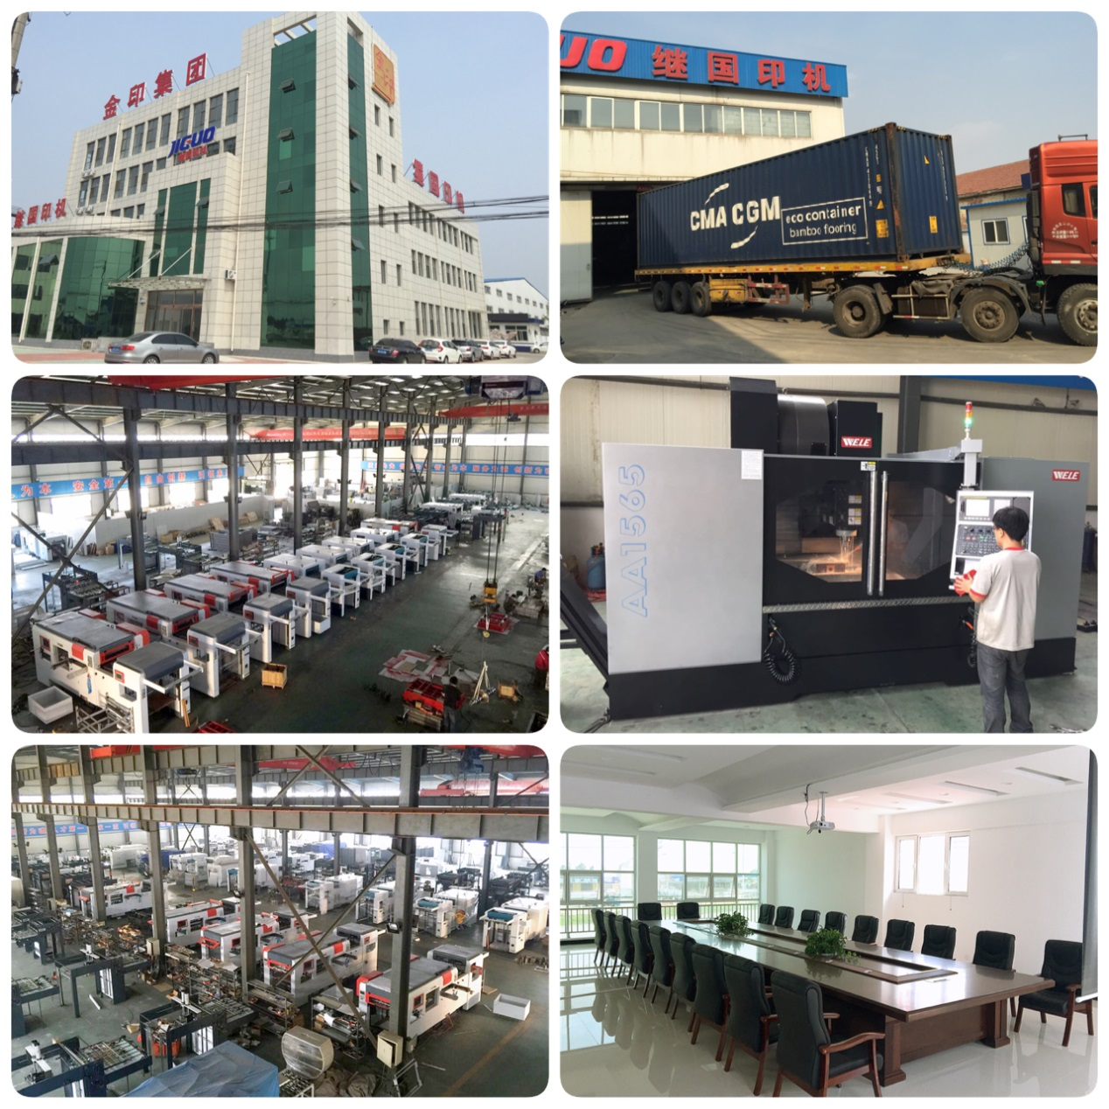

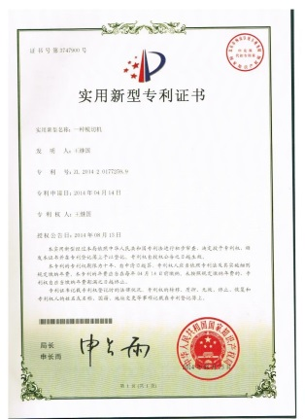
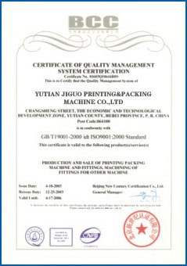
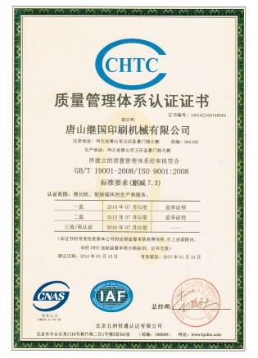
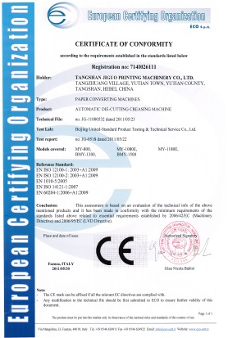

Contents

- Company Profile
- Details Specifications
- Configuration Information
- Description of the Entire Product
- Paper Feeding Unit
- Die-cutting Unit
- Paper Collecting Unit
- Paper Stripping Unit
- Electrical Control Unit
- Accessories
- Accompanying documents
- Accompanying tools
- Additional accessories and consumable spares
- After-sale Service Commitment

- Company Profile
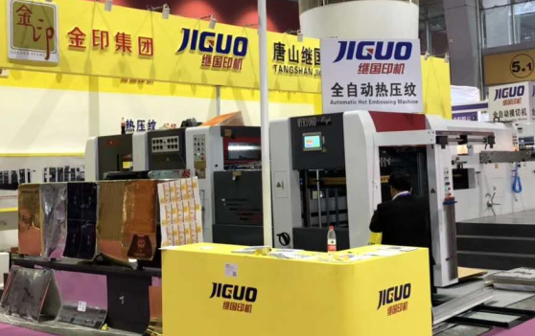
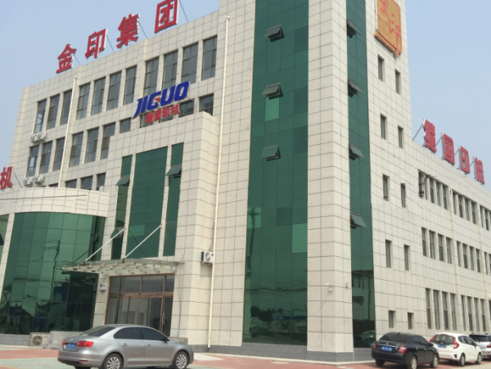
Tangshan JIGUO printing machinery Co., LTD., founded in 1996, is a high-tech enterprise started jointly by a number of senior engineers, and is located in the central area of YuTian County within the golden triangle economic zone consisted by Beijing, Tianjin and Tangshan city with 42.81 mu area covered. Our company has a technical team consisting of 160 elite personnel who contribute to our strong technical power, high level skills of design, assembly and manufacturing, perfect management system and advanced processing and testing equipment. Our company is specialized in production of post-print paper packaging equipment, and has established long-term scientific cooperation for die-cutting machine schemes with the Beijing Institute of Graphic Communication. The company is a modern enterprise incorporating the design, research and development, sales and service. There are two subsidiaries, respectively engaged in machinery parts processing and other printing equipment manufacturing, such as creasing matrix, etc.
Our company adheres to the ideas "Technology boosts enterprise” and "Create first-class products". Advanced management concepts and ideas regarding talents as the base, technology as the soul, quality as the foundation, brand as the flag, marketing as the power and service as the source of the company, contributes to rapid development of our enterprise. Our products have passed the ISO9001 quality certification and the CE certification. We are now mainly producing MY-800H/1060H/1080E/1200E/1320A/1500A/1680ASQ automatic die-cutting and creasing machine(with stripping unit), TMY-800H/1080H/1320H automatic die-cutting and foil stamping machine, BMY1320/1500/1680A Semi-automatic die-cutting machine(with stripping unit) and size 1300/1450/1600（Semi）automatic flute laminating machine, TC-760/1100/1500A/B/C Automatic windows patching machine, saw machine, creasing matrix and many other post-press equipment. Since its establishment, Tangshan JIGUO printing machines have attended hundreds of large exhibitions at domestic and abroad, and have won many honorary awards in the industry and received thousands of praises from domestic and international packaging enterprises. Attended all the big exhibition in domestic Beijing, Shanghai, Guangzhou. And the big exhibition in India, Egypt, Iran, Brazil, Turkey, Russia and so on. We have now grown into a well-known domestic post-press equipment manufacturing expert.
Since first launched in market in 1996, with stable quality and reasonable price, our products have received many praises for our quality and reputation. Our company has become an internationally famous enterprises with products sold well all over the country and exported to over 20 countries and regions, including the United States, South Korea, Russia, India, Thailand, Peru, Egypt, Turkey and so on. JIGUO die-cutting series products are the star products of our company. Taking quality as the lifeline, we have manufactured post-press die-cutting machines with superior quality, low price and high cost performance both at home and abroad. With a high starting point and high standard, we have been incessantly pursuing our dream; with excellent quality, preferential prices and excellent service, we have been cooperating with friends at home and abroad closely to obtain mutual benefit and reciprocity, and create a better tomorrow.
- Details Specifications
Specifications sheet
Model | MYP-1500Q
Max. Paper Size | 1500×1105mm
Min. Paper Size | 500×420mm
Max. Cutting Size | 1480×1090mm
Max. Pressure | 350T
Sheet Thickness | Corrugated Board<10mm (max.thickness)
Max. Die Cutting Speed | 5500sheets/h
Max. Stripping Speed | 5000sheets/h
Die-Cutting Precision | ±0.2mm
Min. Gripper Edge | 8mm
Max. Delivery sheet piles | 1500mm
Total power | 23.5KW
Weight | 25T
Overall Dimension | 9800×4600×2600mm

- Configuration Information

NO. | Name | Brand | Producing area & comment
1 | Main worm & worm wheel | M10 | Korean bearing steel，after quenching, wear to worm, Taiwan-owned processing
2 | Intermittent mechanism | TAN TZU | Taiwan-owned production
3 | Die cutting steel plate | 7mm | Korean material 75Gr1
4 | Main chain | Iwis | Germany
5 | Other chains | TYC | Taiwan
6 | Pneumatic clutch | OPMI | Italy
7 | High-speed joint | SMC | Japan
8 | Screws | 12.9 level | Taiwan
9 | Bolt type track rollers | SKF | Sweden
10 | Bearing 30311 | SKF | Sweden
11 | Bearing 32016 | SKF | Sweden
12 | Bearing 57941/10 | SKF | Sweden
13 | Bearing 6016-2Z | SKF | Sweden
14 | Bearing 6212-2Z | SKF | Sweden
15 | Bearing 6214-2Z | SKF | Sweden
16 | Bearing 6218-2Z | SKF | Sweden
17 | Bearing 6219-2Z | SKF | Sweden
18 | Bearing 63202-2Z | SKF | Sweden
19 | Bearing 80202 | SKF | Sweden
20 | Bearing 80208 | SKF | Sweden
21 | Bearing 80209 | SKF | Sweden
22 | Bearing 80210 | SKF | Sweden
23 | Bearing 80216 | SKF | Sweden
24 | Bearing 80307 | SKF | Sweden
25 | Bearing 6311 | SKF | Sweden
26 | Other Bearings | NSK | Japan
27 | Frenquency converter | TOSHIBA | Japan
28 | Programmable logic controller | OMRON | Japan
29 | Oil pressure switch | Southman | Japan
30 | Photoconductive switch | OMRON | Japan
31 | A.C. contactor | Schneider Electric | France
32 | Thermorelay | Schneider Electric | France
33 | Air switch | Schneider Electric | France
34 | Button | Schneider Electric | France
35 | Human-computer interface | TELTA | Taiwan
36 | Motor GV-40-750-200SM | WANSHSIN | Japan
37 | Motor GV-32-400-200SM | WANSHSIN | Japan
38 | Lubrication System | GOLDKA | Taiwan
39 | Gas Path System | SUNRISE | Taiwan
40 | Vacuum Pump | EUROVAC | Taiwan
41 | Relay | IDEC | Japan
42 | Solenoid Valve | AirTAC | Taiwan
For any needs of technology improvement, company keeps the right to change above information
- Descriptions of the entire product
Automatic die-cutting & stripping machine is the key device for the production of cartons, paper boxes and high standard paper products, etc. It is especially applicable to the automatic die-cutting and stripping of complicated paper boxes and cigarette cases to rationalize the production of paper boxes. This machine is integrally assembled, transported and mounted, it can be put into operated in one day, and thus the cost is reduced. The precise assembly and high configuration make it better than Taiwan machines and competitive with Japan machines.
1、Paper Feeding Unit
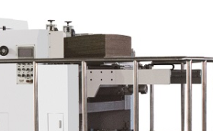
- The high precision lead edge feeder, can adopt to different requirement of the different paper. Frequency conversion control wind volume adjustment. Wind suction area can adjust according to the paper size with high-power fan.
- The forward, backward, light and low positions can be adjusted according to the stock for smooth feeding of thinner paper, large gram cardboard and corrugated paper etc.
- Top speed can be reached at 5500s/h. Die cutting precision is within ± 0.18mm.

- Paper Conveying Unit：
1）The paper conveying part is made of stainless steel plate to prevent rust and provide stable and correct paper conveying.
2）Paper is positioned by a pushing unit and a pulling unit which can be shifted conveniently for different specifications of paper.
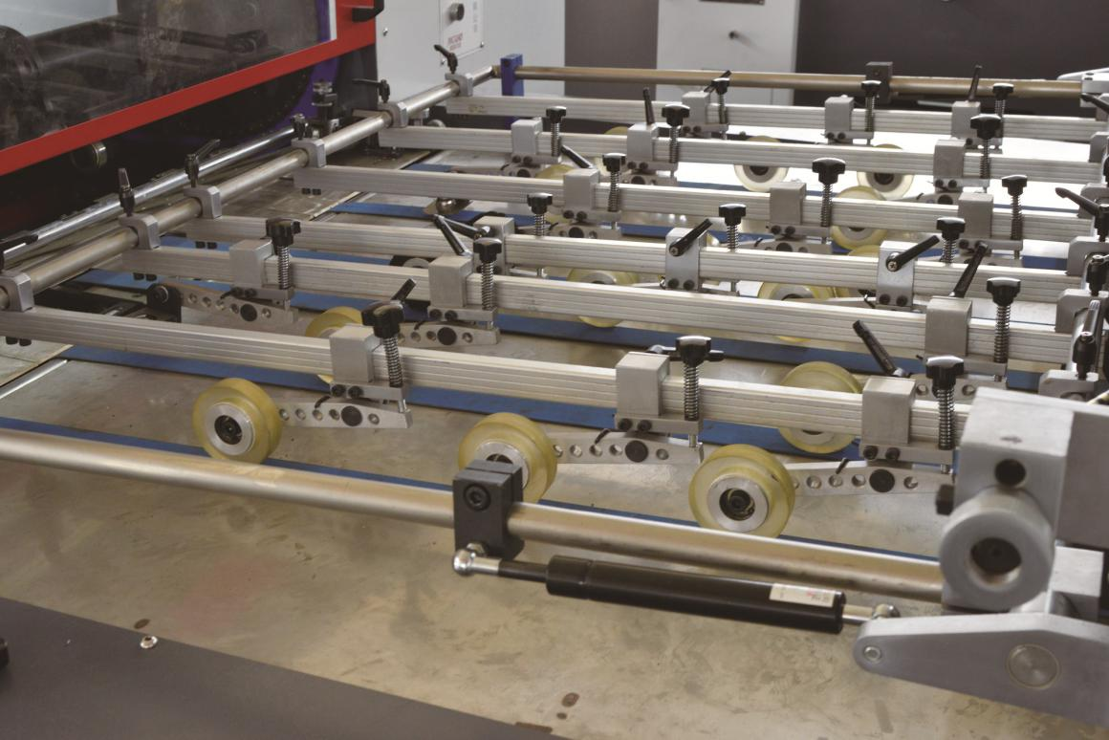
3、Die-cutting Unit

- The cast wall plate is rejected because of its low pulling force but high deformation, and steel wall plate is applied like Japan machines. The pulling force is enlarged, i.e. the pressing force is enlarged, and it becomes firm and endurable without any deformation.
- This machine is upgraded to a brand high level by the automatic pressure regulation and automatic front scale regulation. The addition of this function upgrades it into a convenient and favorable digital device with high controlling speed.
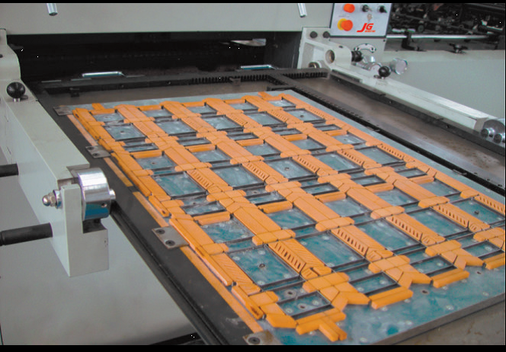
- The oil route is forcibly lubricated by a HP oil pump as made in Taiwan to reduce wearing, an oil cooler is added to cool the lubricating oil, and the main chain is lubricated timely to improve the operation efficiency.
- The novel transmission mechanism provides high speed die-cutting, and the highly precise swing link platform improves the padding speed (almost without padding), as it is known the pressure can be hardly balanced in most of other common machines.
- The pneumatic plate locking unit can fix the upper frame more firmly and faster. In our die-cutting machine, the front, back, left and right are pneumatically locked simultaneously to realize a high correctness and a high speed. However, common machines are tightened by screws.
- The paper holding rack chain is imported from Germany, which provides a long service life and a stable die-cutting precision.
- The Taiwan intermittent mechanism is the main transmission part of the die-cutting machine, and it improves the die-cutting speed and precision and reduces the device noise, while the speed and precision cannot be realized by any domestic mechanism.
- The torque limiter is equipped with overload protection. The primary and secondary units can be separated at any overload to ensure the machine can be operated safely. The Italia pneumatic brake and clutch with Japan SMC rotary joint comply with the European standard. They provide fast clutching, high and stable force, long service life and low noise.
- Paper Collecting Unit
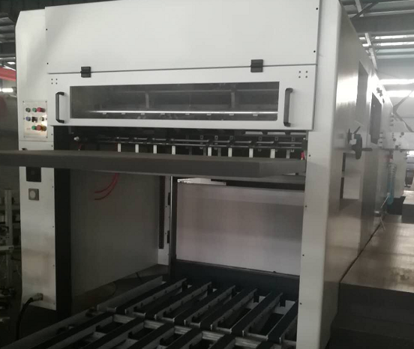
- Paper can be collected automatically and orderly.
- The efficiency is improved by an uninterrupted paper collecting grid plate, and when paper is stacked to the specified height, the paper collecting grid plate will be replaced by another plate for uninterrupted paper collecting.
- By the pneumatic sampling, the die-cut paper can be conveniently inspected at any time.
4、Paper Stripping Unit
- By the one-time stripping system, all irrelative paper scrapes and waste edges (except the held margins) can be stripped in die-cutting.
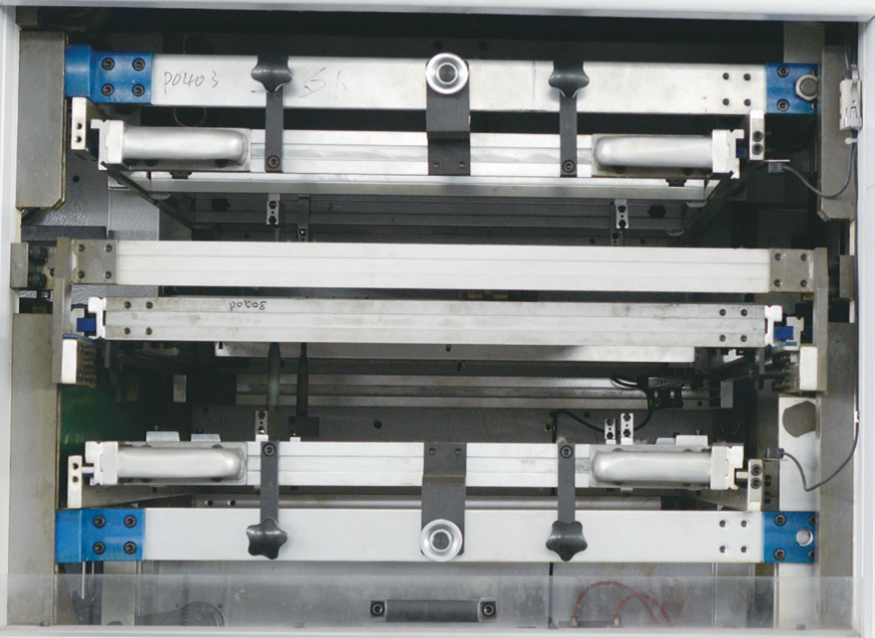
- The up, down and middle die cam tri-link transmission system is stable, harmonious, and correct for high power and fast loading, unloading and calibrating.
- The stripping frame is pneumatically lifted with a centering unit, and it can be operated easily to shorten the preparation time.
- The preliminarily loading platform is equipped with a centering unit to facilitate the mounting of stripping plate.
- The stripping process is reasonably designed to eliminate the defect of low speed and plate deviating during stripping.
5、Electrical Control Unit
- The electrical control system is Japan Omron PLC computer automatic control for fully detecting and controlling, and the Japan TOSHIBA frequency converter with Taiwan main motor provides high power for paper feeding, paper conveying, die-cutting, and paper collecting.
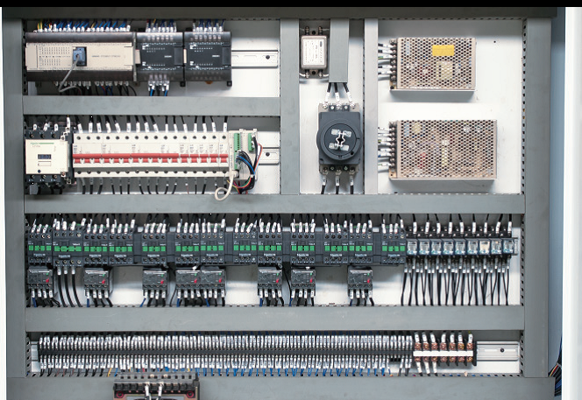
- The human-machine interface can display various working conditions, indicate fault positions and give solutions.
- The machine is equipped with various safety protection units. A visible and audible alarm will be given at any fault, and the machine will be automatically shut down to protect personal and device safety.

- Accessories
1、Accompanying tools
Name | Quantity | Specification
Flat screw driver | 1 piece | 150
Cross screw driver | 1 piece | 150
Monkey wrench | 1 piece | 300
Allen wrench | 1 set
Socket spanner | 1 set | 6-27
Sway spanner | 1 piece
Steel plate handle | 1 piece
Hammer | 1 piece
Engine oil can | 1 piece
Pressing oil gun | 1 piece
Tool box | 1 piece
2、Additional accessories and consumable spares
SN | Name | Quantity
1 | Fixed gripper finger | 10 pieces
2 | Mobile gripper finger | 10 pieces
3 | Spring piece | 10 pieces
4 | Sucker rubber | 16 pieces (2 sets, 1 for large and 1 for small)
5 | Sheet separator | 12 pieces (2 sets, 1 for thick and 1 for thin)
6 | Electrical banding tape | 5 pieces for large and small each
7 | Semicircular head screw M6×8 | 8 pieces
8 | Expansion bolt M8 | 2 pieces
9 | Buckle Ø30 | 8 pieces
10 | Paper feeding plate | 1 set
11 | Brush wheel (hard hair) | 4 pieces
12 | Paper dividing hair brush | 2 pieces
13 | Paper pressing plate | 1 set
14 | Torsion spring (A0714A.A0714B) Ø2.5 | 7 pieces for each
15 | Rubber padding plate 200×200 | 6 piece
16 | Pushing scale LG31.LG32 | 1 piece for each
17 | Paper barrier C0637B | 2 pieces

VI、After-sales service commitment
Respected users of JIGUO printing machine:
JIGUO Printing Machine after-sales service give our heartfelt thanks to you for your choice of our products and solemnly promise you: we will provide satisfactory and considerate service for you.
In order to guarantee your normal use of the die-cutting machine and acquisition of good after-sales service, please carefully read the commitment made in this manual, for this commitment is an important accessory file delivered with user’s manual, factory certificate and packing list. It is an important basis to guarantee your after-sales service, therefore please keep this manual and act in accordance with provisions in this manual.
A. Our company has executed an all-the-way tracking management system during the period from product delivery to expiration date. Specific measures are as follows:
1、Establishing product technical record management system:
One set of documents for each machine, including acceptance certificate of assembled products, product delivery status, responsible personnel of product installation and commissioning, usage training and qualification certificate, warranty, record of technology and quality status during the guarantee and maintenance period and record of analysis and problem solving process, which can ensure guaranteed operation of each die-cutting machine sold.
2、After-sales service guarantee system
- Equipment installation and commissioning:
Our company will send professional engineers responsible for equipment overall installation and commissioning.
- Technical training:
After equipment arrives at your place, we will provide free training to two operators with technical training materials specially compiled. Professional trainers will be responsible for the training. Main training contents are:
Structure introduction of the die-cutting machine, structure and adjustment method of paper feeding, structure of the mainframe, adjustment method of the die-cutting pressure, structure and adjustment method of paper collection, installation of die-cutting plate and plate placing method, usage and attentions of various operating switches, daily maintenance and other courses.
After the training is completed, assessment of theory and practical operation will be given to operators to see whether they can operate machine skillfully and have understood principle of mechanical properties. Certificate will be given to operators who can carry out routine operations and maintenance. This certificate makes final decision on whether operators can become trainers in order to ensure the normal operation of machine later.
- Time-limited maintenance:
If temporary fault occurs in mechanical system, technical service personnel would make phone call to inquire and solve the problem on receipt of your notice. For unsolved problem, technical service engineers would arrive on your scene within 24 hours if the scene is within 150km of our company; if it is not, engineers would arrive in 48 hours (only for domestic market).
- One year of free repair guarantee,and one years of warranty, provided the spare parts during guarantee free of charge. and lifetime quality assurance:
From the day of your purchase, our company will provide you with free commissioning, maintenance and parts replacement service within one year, but we will charge cost of main parts if the accidents are caused by improper operation instead of mechanical quality.
After guarantee, we will provide technical support for all faults occurred in your machine and charge for repair service, including fault repair and original parts replacement.
B. This guarantee has legal effect and will not become invalid from company’s development and change.
C. Guaranteed by the JIGUO brand, we will continue to provide quality guarantee commitment to you.

